🚗 Car Price Prediction using Linear Regression
📊 Project Overview
This project presents a fundamental implementation of Linear Regression to predict car prices based on the manufacturing year. It demonstrates the end-to-end machine learning workflow, including data preparation, model training, prediction, and visualization. The project is designed to build a strong foundation in predictive analytics using Python.
📝 Abstract
Accurate price prediction is a key application of machine learning in domains such as automotive sales, finance, and market analysis. This project explores the use of a Linear Regression model to establish a relationship between car manufacturing year and its corresponding price. By training the model on historical data, it enables prediction of future car prices based on user input. The project also incorporates data visualization to illustrate trends and model behavior. This implementation highlights the effectiveness of simple regression techniques in solving real-world prediction problems and demonstrates the importance of data-driven decision-making.
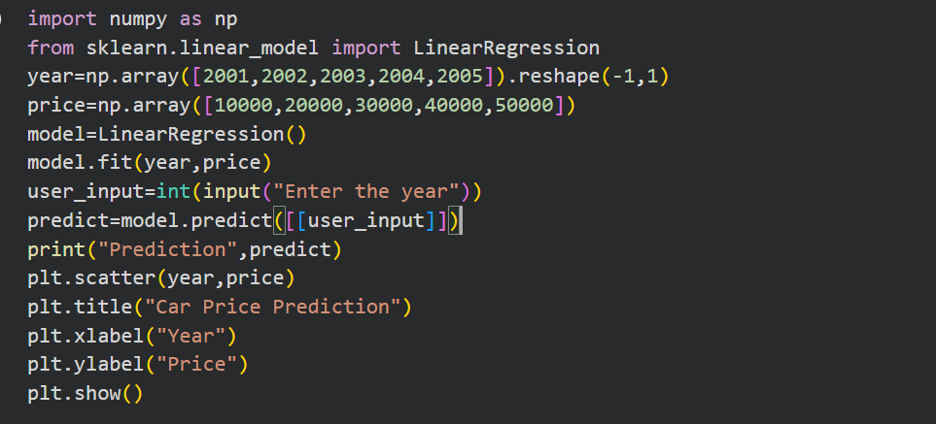
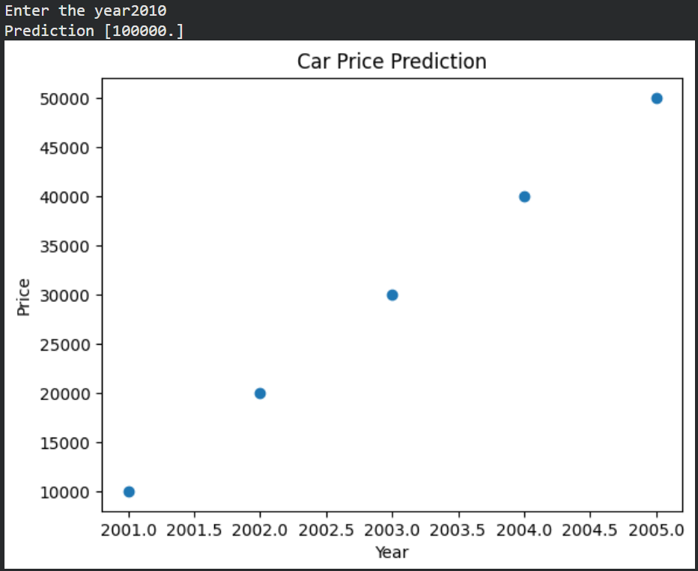
🎯 Objectives
- Implement Linear Regression using Python and Scikit-learn
- Predict car prices based on year input
- Visualize the relationship between variables
- Understand basic machine learning concepts and workflow
🛠️ Technologies Used
- Python
- NumPy
- Scikit-learn
- Matplotlib

📂 Dataset Description
A sample dataset is used to demonstrate the model:
YEAR | PRICE
2001 | 10000
2002 | 20000
2003 | 30000
2004 | 40000
2005 | 50000

⚙️ Methodology
- Import required libraries
- Prepare input (Year) and target (Price) variables
- Train the Linear Regression model
- Accept user input for prediction
- Generate predicted output
- Visualize data using scatter plot
📈 Output
- Predicts car price for a given year (e.g., 2010 → 100000)
- Displays a scatter plot showing the linear relationship between year and price
🔍 Key Insights
- A strong linear trend exists between year and price
- The model effectively extrapolates future values
- Visualization improves interpretability of model behavior

✅ Conclusion
This project successfully demonstrates the application of Linear Regression for predictive analysis. It serves as a foundational example for beginners to understand model building, prediction, and visualization. The approach can be extended to more complex, real-world datasets with multiple influencing factors.
🚀 Future Scope
- Use real-world datasets with multiple features (mileage, brand, condition)
- Apply advanced regression techniques
- Evaluate model performance using metrics (R², RMSE)
- Develop a web-based interface for predictions
🙏 Acknowledgement
This project was developed as part of learning machine learning concepts and demonstrates practical implementation of regression techniques using Python.

